Preemptive.

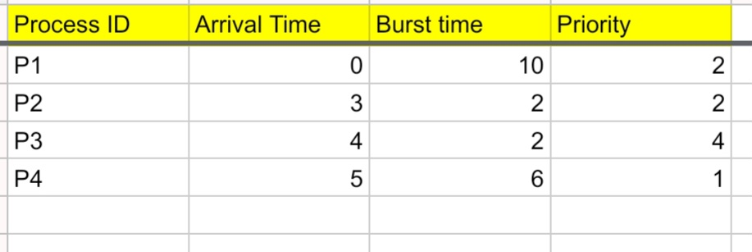

SJF
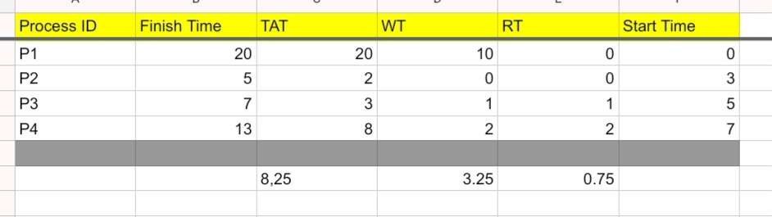

_{TAT1=20-0=20}
_{TAT2=5-3=2}
_{TAT3=7-4=3}
_{TAT4=13-5=8}

_{ATAT =(20+2+3+8)/4=8.25}
_{WT1=20-10=10}
_{WT2=2-2=0}
_{WT3=3-2=1}
_{WT4=8-6=2}
_{AWT=(10+0+1+2)/4=3.25}

_{RT1=0-0=0}
_{RT2=3-3=0}
_{RT3=5-4=1}
_{RT4=7-5=2}

_{ART=(0+0+1+2)/4=.75}

_{Priority}

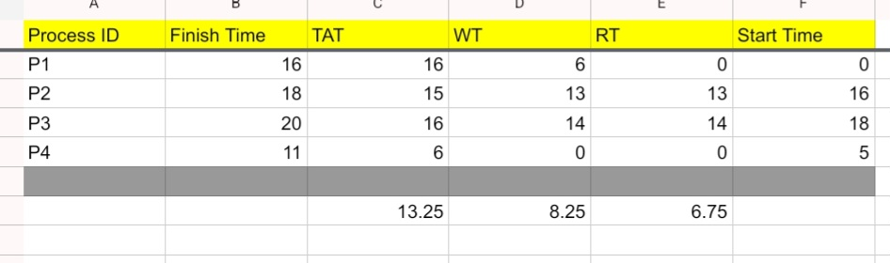

_{TAT1=16-0=16}

_{TAT2=18-3=15}

_{TAT3=20-4=16}

_{TAT4=11-5=6}

_{ATAT =(16+15+16+6)/4=13.25}

_{WT1=16-10=6}

_{WT2=15-2=13}

_{WT3=16-2=14}

_{WT4=6-6=0}

_{AWT=(6+13+14+0)/4=8.25}

_{RT1=0-0=0}

_{RT2=16-3=13}

_{RT3=18-4=14}

_{RT4=5-5=0}

_{ART=(0+13+14+0)/4=6.75}

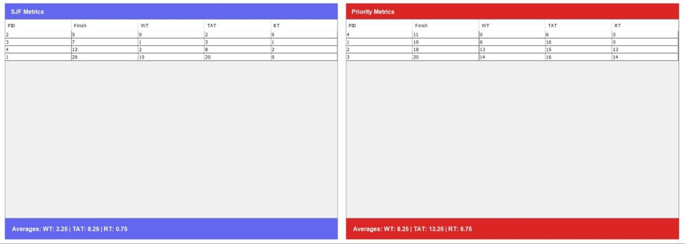

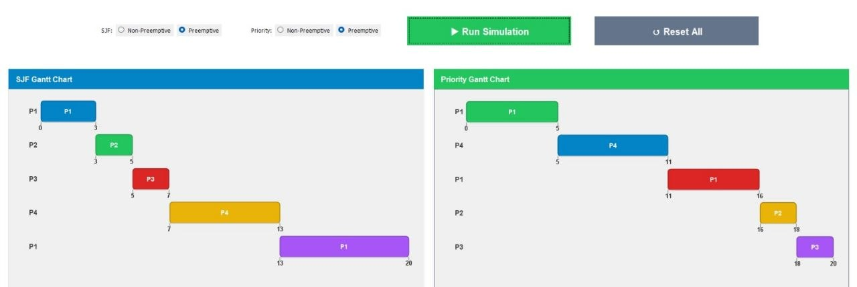

_{Non Preemptive.}


_{SJF}
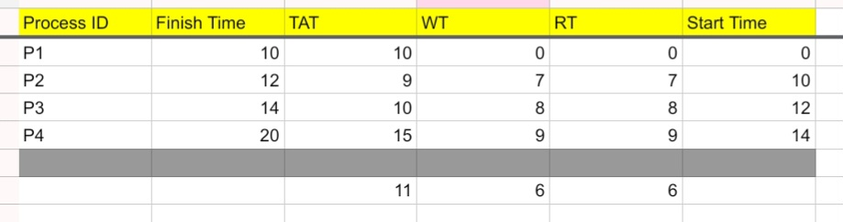

_{TAT1=10-0=10}
_{TAT2=12-3=9}
_{TAT3=14-4=10}
_{TAT4=20-5=15}

_{ATAT=(10+9+10+15)/4=11}
_{WT1=10-10=0}
_{WT2=9-2=7}
_{WT3=10-2=8}
_{WT4=15-6=9}
_{AWT=(0+7+8+9)/4=6}

_{RT1=0-0=0}
_{RT2=10-3=7}
_{RT3=12-4=8}
_{RT4=14-5=9}

_{ART=(0+7+8+9)/4=6}

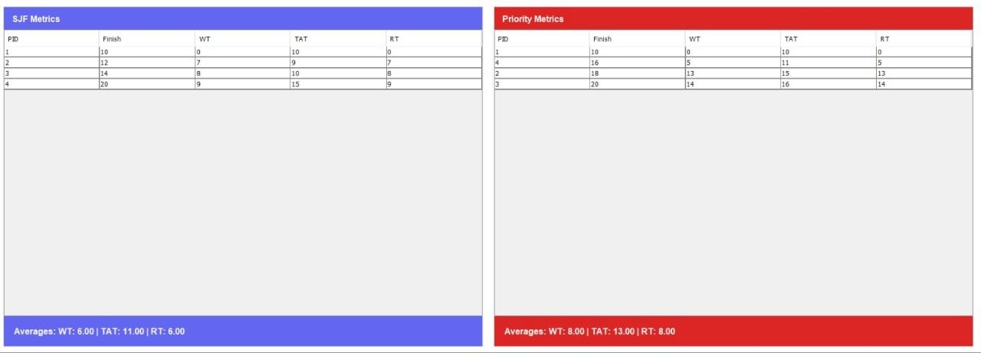

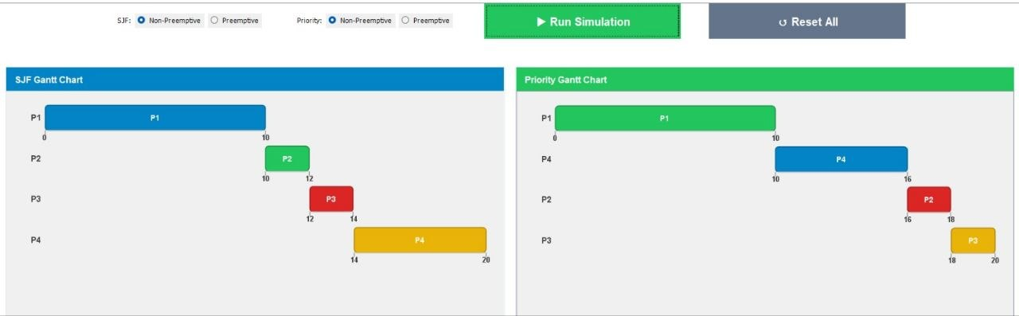

_{Priority}
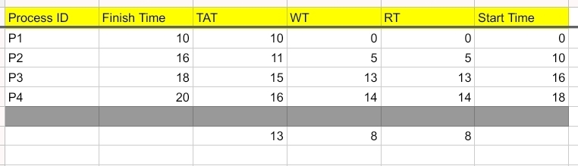




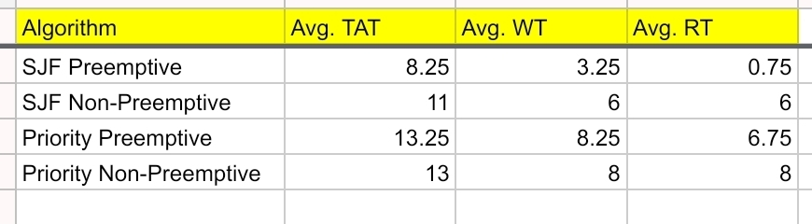

Based on the simulation results, the SJF (Preemptive) algorithm demonstrated the highest efficiency by achieving the lowest Average Response Time (ART = 0.75) and a significantly reduced Average Waiting Time compared to other methods. While the Priority-based algorithms adhered to the assigned process importance, they resulted in a noticeable increase in waiting and turnaround times. This highlights the fundamental trade-off in operating systems between optimizing for shortest execution time and maintaining strict priority requirements.

